UW International Course
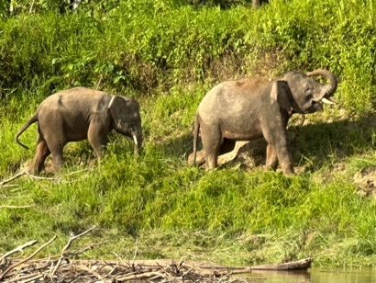
Bornean elephants along the Kinabatangan river
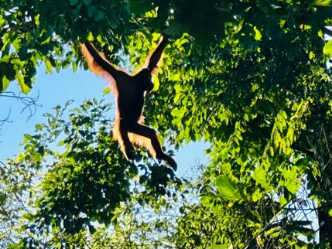
Orangatan at a restoration site.
Biodiversity Conservation in Borneo
BOT 4790/5790 3 Credits
May 19 – June 6, 2026

Travel to the tropical forests of Borneo and experience one of the most biologically rich and dynamic ecosystems on Earth. Along the Kinabatangan River in Sabah, Malaysia, students will encounter Bornean pygmy elephants, orangutans, sun bears, proboscis monkeys, and hornbills while learning how communities are restoring tropical forests to sustain both biodiversity and livelihoods.

Working with community-based conservation leaders in Batu Puteh, students will plant native forest trees and measure their physiology and their invasive competitors and quantify biodiversity recovery of mammals, birds, and insects. You’ll also visit an oil palm plantation and processing facility to explore the economic realities and trade-offs that shape conservation and land use across Borneo.

Students will stay at Danau Girang Field Station, reachable only by boat, and travel by river to restoration sites, forest fragments, and conservation centers such as the Bornean Sun Bear Conservation Centre. A highlight of the journey will be a visit to the Gomantong Caves, home to millions of bats whose evening flights attract spectacular aerial hunts by birds of prey. The caves are nestled in mostly intact tropical forest whose massive trees form the living framework supporting the bats, birds, and other wildlife of this ecosystem.

The 2025 course culminated in a student Borneo Art Show featuring photography and video. The 2026 course will continue this tradition, combining field research, cultural immersion, and creative interpretation to deepen understanding of tropical biodiversity and restoration.
The approximate total cost of the course is $4,000. Donor-supported awards from the Botany Department and the Biodiversity Institute will be available to help offset course costs and course registration fees.

You must apply at UW’s Study Abroad website (https://uwyoabroad.via-trm.com/program_brochure/22942) by February 11th. For questions, contact Professor Brent Ewers (beewers@uwyo.edu) and teaching assistant Mason Lee (mlee37@uwyo.edu).
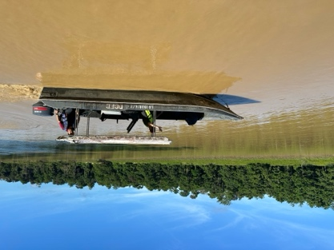
Danau Girang boat leaving the field station.
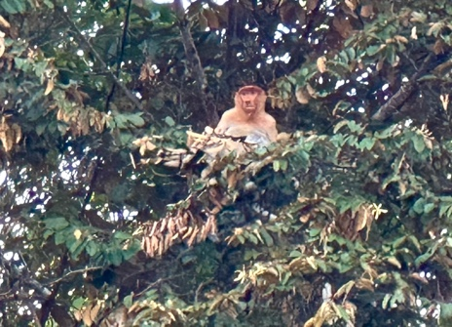
Proboscis money in a Bongkol tree at a restoration site.
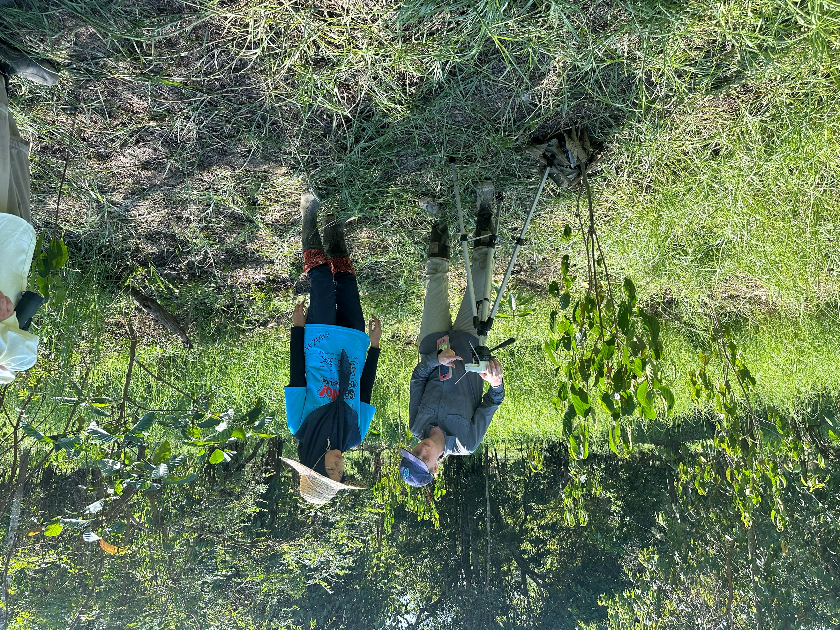
Taking measurements with community members at a recently restored site.

