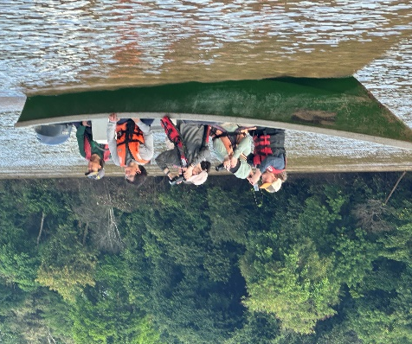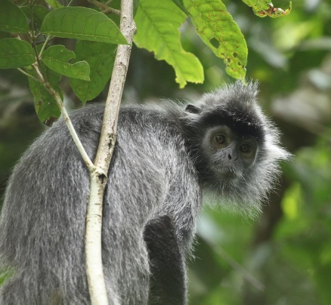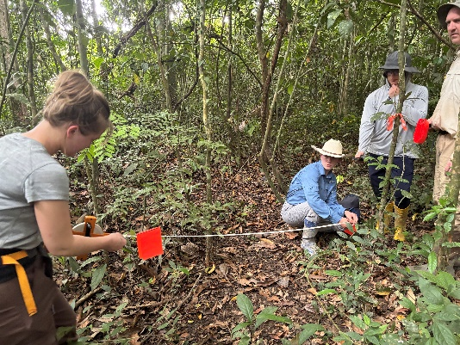Biodiversity Conservation in Borneo International Course
2026 Global Seminar Awards Application
The University of Wyoming Biodiversity Institute and Department of Botany invite applications for partial or full awards to support student participation in the 2026 Biodiversity Conservation in Borneo International Course, offered as a UW Global Seminar.
These awards are intended to reduce financial barriers and support student participation in this field-based international course.
Eligibility and Application Process
To be considered for a Global Seminar Award, applicants must first apply to the course through UW’s Study Abroad website (https://uwyoabroad.via-trm.com/program_brochure/22942) no later than February 11, 2026.
Award applications should be submitted as a single PDF document, no longer than two pages, and emailed with subject “Borneo Global Awards Application” to:
Brent Ewers (beewers@uwyo.edu) & Mason Lee (mlee37@uwyo.edu)
Deadline: 5:00 pm on February 13, 2026
Award Decisions
Award decisions will be based on application responses and available funds. Multiple full and partial awards will be made, with support provided by both the UW Biodiversity Institute and the UW Department of Botany.
Application Questions
Please address the following questions in your two page PDF:
1. Name 2. Major 3. Class standing (e.g., junior, senior, year graduate student)
4. Why do you want to participate in the Biodiversity Conservation in Borneo International Course?
5. How will participation in this course support your academic and/or professional goals?
6. Describe a time when you encountered challenging conditions in the field (e.g., weather, terrain, wildlife, interpersonal dynamics) and how you navigated those challenges. If you do not have field experience, describe a comparable situation involving unexpected challenges and how you responded.

