**Aspen Reproduction Patterns in the Medicine Bow National Forest**

Kristina Edwards - December 12, 2012

**Introduction**

Aspens are among the most important organisms in the Rocky Mountain ecosystems. They provide food and shelter for various members of their community, making them what is called a keystone species. Their very existence is essential to the ecosystem’s survival. In addition, aspens can create a natural barrier that in some instances help to prevent the spread of wildfire. Economically, aspens are also often used to produce chipboard, a common commodity in construction and development (Shepperd, W.D. 2001).

The jack of all trades, aspens grow widespread in regions all over the Earth. Aspen groves consisting of the aspen species *Populus tremuloides* are commonly found in most elevations across most of North America in areas best suited for their growth, such as regions with prolonged exposure to sunlight and water. It has also been observed that aspens tend to grow in higher altitudes during the summer, likely due to the abundance and availability of sunlight at this time. This species of aspen is very similar to *Populus tremula,* a tree found in Northern Europe and parts of Asia; however, small differences separate the two in classification (M., Grant 2010).

Aspens are unique in the sense that they have the ability to reproduce both sexually and asexually. Most trees reproduce sexually through the joining of two opposite haploid cells to create a new organism. Aspens have this capability as well. Each individual aspen is of a distinct gender that produces their gender specific type of haploid cell which can be carried on the wind until matching up with an opposite haploid cell and settling to become a new, genetically independent tree.

Although aspens have this ability, they often reproduce asexually, forming raments, or individual trees, that are genetic copies of the original (K. E. Mock 2008). In the asexual reproduction process, an existing aspen tree shoots up small sprouts that are connected to the parent tree through the root system which eventually grow up into full trees that are genetically identical to the parent tree. In this way, many clusters of trees are formed, creating large groves of aspens as new trees continually produce more clones (Kemperman, J, Barnes, B 1976).

This nature of the aspens, added to their ability to reproduce sexually, raises many questions about aspens as a species and their living patterns. The research done on this topic is new information that may give insight to this keystone species and its importance to ecosystems everywhere. The growth patterns of these aspens and their genetic information can be observed and tangibly collected in order to answer many of these questions about them and their reproduction.

Due to the cloning abilities of aspens and the observed resulting growth patterns, the question arises as to whether all trees in a grove of aspens are genetic clones. It also follows that, since separate groves of aspens exist in a certain area of land, it would be asked whether each grove is a genetically individual clone of trees. The experiment and research done in this instance tested hypotheses for both of these questions: all aspen trees in a grove are clones, and each grove is an individual genetic clone of trees.

**Methods and Materials**

The initial research for this study was done at a site in the Medicine Bow National Forest, the exact location being 41° 11’ 19.59”N, 105° 23’ 35.27” W, which encompassed seven prominent groves of *Populus tremuloides*. Small groups of researchers disseminated out to each of the groves to take measurements that included the surface area covered by the grove, the number of trees in each grove, and the diameters of various tree trunks of various sizes within the groves. Three trees were selected from each grove, and samples of DNA were taken in the form of green leaves or leaf buds, selected because of their good color and therefore their great likelihood to have living, viable DNA. Each of the three trees selected from each grove were also chosen to ensure that samples came from trees distributed evenly throughout the grove, and that the trees ranged in size from small to large to ensure a diverse data pool for each grove. A list of each grove and the selected trees are as follows, including each tree’s individual name and the two or three character abbreviation to which it is referred in the results of the experiment.

**Bertha** **Forbidden Forest**

Unnamed Bertha 1* BA Remus Lupin F1

Unnamed Bertha 2* BB Severus Snape F2

Unnamed Bertha 3* BC Colin Creevy F3

Edge-Grove+Meadow* B4 **Outlier**  O

Road Edge B5 **Rocky Balboa**

Middle/Bertha B6 Papa 1 R1

**Big Happy Family** Papa 2 R2

Big Mama BH1 Charlie R3

Little Lou BH2 **Woody**

Junior Johns BH3 Large WL

*Trees whose DNA was collected Medium WM

One year prior to current report Small WS

These samples were carefully stored until the researchers were able to perform DNA extraction on them, which took place at the Berry Biodiversity Center on the University of Wyoming campus using the DNeasy Plant Kit manufactured by Qiagen Company. This allowed for the DNA from each sample to be isolated into a usable form that could be examined and analyzed to determine a pattern that would either support or refute the stated hypotheses. These DNA samples were again carefully stored until the next step was ready to be taken in this experimentation process.

The next step for the DNA was PCR, a process in which DNA is “unzipped” and replicated. The purpose of this was to produce enough usable DNA so that all of the proper tests could be run without worrying about running out of samples. The PCR process was completed in a classroom setting using the Promega Go Taq PCR Master Mix. The DNA PCR was done using a variety of Primers to help begin the PCR process. Below is a list of all of these primers and their coding. A variety of primers were used to ensure that the results were clear and comprehendible.

Primers:

843 (CT)8RA Omar (GAG)4RC

844 (CT)8RC Terry (GTG)4RC

902 (GT)6AY AW3 (GT)6RG

The final results of the experiment were visualized through the process of gel electrophoresis. A gel substance was created using 1% agarose and ethidium bromide. The many prepared samples of the various primers were carefully measured into wells with DNA ladders spaced evenly throughout that set a size and appearance standard for the other samples. Using a charged chamber, the DNA was dragged out over the gel, showing in the end pictures of DNA fragments of assorted sizes. These fingerprints are used to determine similarities and differences in genetics between the DNA samples. This was the form taken by the final results of the experiment, and it was left up to the researchers to interpret them and their meaning within the context of this experiment.

**Results**

Following are six figures representing the final data of the research and the analysis of that data. Each figure is labeled, and an explanation of each figure follows its appearance on the report. Each piece shown was a vital step in processing the yielded data and coming to conclusions.

Figure 1.1-Scans of gel electrophoresis images

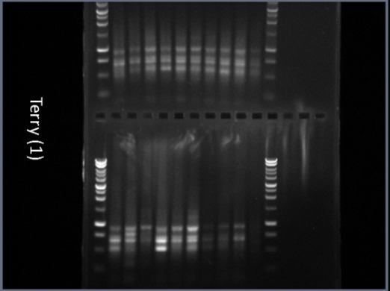 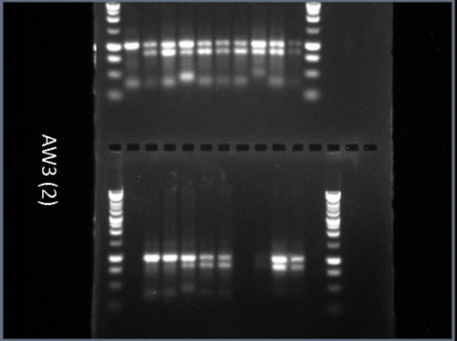

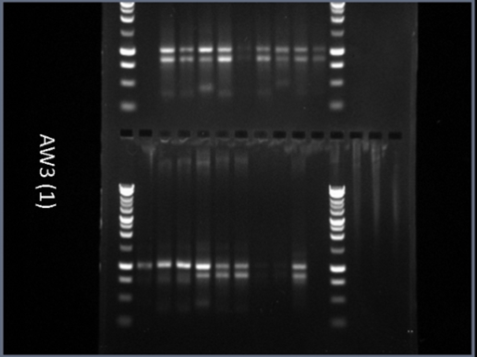 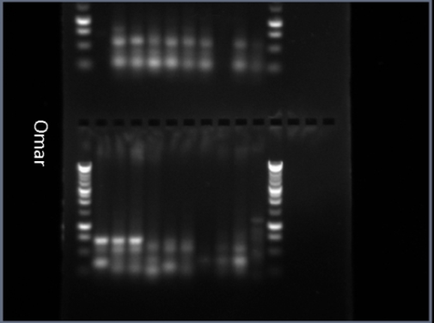

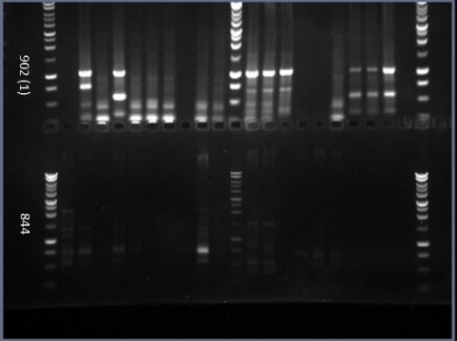 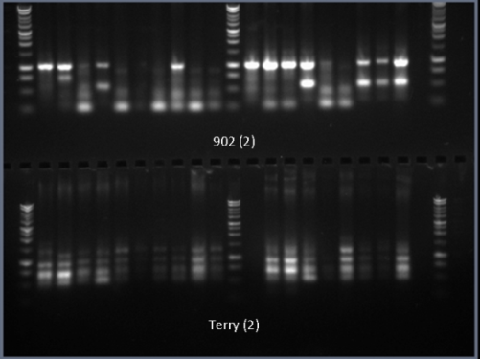

Figure 1.1-These are scans of the gel electrophoresis images that were created after the DNA samples were loaded into their wells and put in a charged chamber. Each scan is labeled with the name of the primer used in that set of DNA samples. Since more than one set had the same primer in some cases, the primers are named with a one or a two next to the name. These names directly correspond to the primer names in the analytic table below. In order to make these images useful for the experimental results, they had to be evaluated. In each primer, the bands of the scan represent a fragment of DNA of its own individual length. By going through a single primer, it can be seen which DNA samples are genetically identical and which ones are not based upon the primer. The full evaluation of these images is shown and explained in the tables and maps below.

Figure 1.2-Data analysis table of gel electrophoresis scans



Figure 1.2- This is a color-coded table created based upon the data gathered from the gel electrophoresis images. Going through one primer at a time, each image was evaluated according to apparent genetic similarities and differences, as described above. All navy blue cells indicate a sample wherein the genetic makeup was impossible to determine from the scans. The last column, marked C for control, yielded no results, as was expected since no DNA was put into those samples. The analysis of this table, a product of the analysis of the gel electrophoresis scan, was fairly simple. By looking down the individual columns, each of which represent DNA from an individual tree, and comparing the genetic results to other trees, it can easily be seen which trees are genetically identical according to each primer. Any discrepancy between two trees has to classify them as being genetically different.

After analysis of this table, it appears that there are three main genotypes of trees in which more than one tree has that specific genetic makeup. These genotypes are tentatively called A, B, and C. Below is figure 1.3, a small table laying out which trees belong to each genotype.

Figure 1.3-Genotype groups of aspen trees in the Medicine Bow Forest

|  |  |  |
| --- | --- | --- |
| **A** | **B** | **C** |
| BB* | F2 | WS |
| B4 | F3 | WM |
| B5 |  | WL |
|  |  |  |
| BH2 |  |  |
| BH3 |  |  |
| R2 |  |  |
| R3 |  |  |
| *BB= BD and all G's |  |  |

Figure 1.3- A table of trees classified into their determined genotypes. The trees in each column are all genetically identical. The colors of each genotype and individual tree correspond to the colors on the map below.

Figure 1.4-Overlay map of Genotypes A, B, and C and their projected ranges

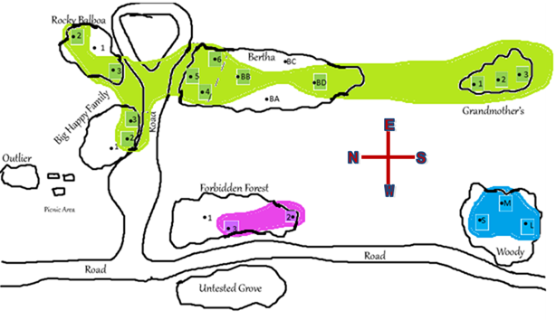

Figure 1.4- This is a generated map of the area studied including the seven main groves in the study area as well as the artificial barriers, such as the road that separates them. Each highlighted number or letter combination is a tree that is genetically identical to all other trees in its color. The shaded areas of the map are hypothesized genotype ranges for each specific genotype based upon not only the placement of identical trees, but also on the placement of genetically different trees. This map and its hypothesized ranges will be largely referred to in the conclusion of the study, and its purpose is to not only show the hypothesized ranges of each genotype, but also to aid as a help for visualization of the results and the patterns that occur in those results in a concise way.

Figure 1.5-Map of tree diameters in the Forbidden Forest

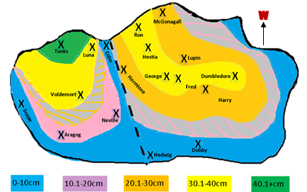

Figure 1.5-A map showing in colored bands the trunk diameter trends of eighteen measured aspen trees in the grove called the Forbidden Forest. The three trees whose DNA was used to compare genetic similarities were Snape, Colin, and Lupin, which are circled in red on the map. This map is the hypothesized explanation of the genetic differences between Snape and Colin, which were identical, and Lupin, a hypothesis that includes the separation of the grove into two separate groves, as indicated by the black dashed line. This map and its possible implications for aspen research will be further explained in the discussion of the research.

Figure 1.6-Table of Forbidden Forest tree diameters



Figure 1.6-The table of values for the diameters of several trees in the Forbidden Forest along with their names. The trees are color-coded according to size in conjunction with the key on the map in figure 1.5.

**Discussion**

The results of this experiment, though conflicting with the initial hypotheses, are enlightening and thought provoking. Neither of the original hypotheses that all aspen trees in a grove are genetic clones of one another and that each grove of trees in an area are their own distinct clones were not supported by this experiment. This is consistent with existing research due to the very nature of aspen trees and their unique ability to reproduce sexually and asexually.

The groves The Forbidden Forest, Bertha, Rocky Balboa, and Big Happy Family all contain trees that are not genetically identical to the other tested trees in the groves. This refutes the first initial hypothesis that all trees in a grove are genetically identical clones. As figure 1.2 shows, some trees are genetically identical to others in their grove in most tested primers, but are different in one or two. This small difference suggests that there is some sort of genetic difference in a specific DNA sequence of the tree that does not manifest itself in other similar trees. Due to these small differences, these trees cannot be considered genetically identical to the others and therefore are not clones of the other trees in their grove.

Data from the Forbidden Forest grove was examined more closely. This grove had two genetically identical trees and one that was very similar genetically with only one primer showing a genetic difference. In an effort to better understand why this happened, the grove was mapped out with each tree that was measured marked with an X in the spot where it stood in the grove. It is widely accepted that the larger the diameter the trunk of a tree is, the older it is. By taking the measurements of the diameters of the trees that were tested and grouping them into ranges, a map was created that linked a tree’s location in the grove with its age.

Looking at this initial color-coded map, it wasn’t clear where any pattern lay, which was illogical, since clones tend to grow out from a single parent tree. It didn’t make sense, that is, until the grove was theoretically split into two, as indicated by the black dashed line on the map above. When this was done, clear patterns of size rings were manifest, as shown again on the map with the different colors. Those gray areas with colored dashes represent the hypothesized size rings that logically would have to exist in each grove. To prove that these age rings do exist, further diameter testing would need to occur. The nearly concentric rings created on the map support the hypothesis of aspen cloning since the youngest trees are furthest from the oldest tree, Tonks, indicating that the grove grew outward from a single old tree.

This map is all hypothesized from the data that was collected, but it does bring up a somewhat logical and intriguing explanation as to why one tree in this grove was genetically different from the two others tested. The trees named Colin and Snape, or F3 and F2, were genetically identical. Within the generated map, these two trees lie in the same individual grove within the Forbidden Forest. Lupin, or F1, was not genetically identical to these two trees, and lies within the other hypothesized grove within the Forbidden Forest. If there were indeed two distinct groves that came together to form the Forbidden Forest, this would fully explain not only the genetic differences in the trees, but also the growth patterns that would not fit with the idea of one large grove in and of itself.

This possibility is very interesting, and may well, if accurate, appear in the growth patterns of other groves as well. The grove Big Happy Family, for example, is very similar to the Forbidden Forest in that it has two trees that are genetically identical and one other that is not. Along with testing this hypothesis on the Forbidden Forest, it would be revealing to see if this same pattern exists in other groves such as Big Happy Family; it is worthy of additional investigation.

Bertha, Grandmother’s Grove, Big Happy Family, and Rocky Balboa were all groves that contained trees of genotype A. This obviously contradicts the second hypothesis that each grove is a genetic individual. By looking at the hypothesized range for Genotype A above, it is clear that genetically identical clones are spread out over hundreds of feet of land, taking part in four geographically separate groves. The implications of this are outstanding, as they suggest that a single aspen tree can create genetically identical clones that can then continue growth and become parts of various separate groves.

An already existent and well-studied example of the enormous growth of aspens is the world’s largest organism, a clone of aspen trees near the Wasatch Mountains in Utah called Pando. Through a huge network of roots, the Pando grove grew from a single tree into practically a forest of Quaking Aspens that covers over 106 acres of land. In estimation, the entire organism weighs about 13 million pounds (Grant, Michael C. 1993). This, the world’s biggest living being, is just one example of the vast growth potential of *Populus tremuloides* and its far reaching influence on ecology.

There is nothing in past research to suggest that this is at all impossible or even unlikely. In fact, the results of this research affirm that cloning in *Populus tremuloides* is common, having three distinct instances of cloning in a small area of groves, and that it is powerful and far spread, as shown by Genotype A. It also gives hints to the past and the location and size of groves hundreds of years ago in that area, indicating in some instances that there is a good possibility that now separate groves were once joined in one large grove and were eventually separated by the creation of physical barriers such as the creek that now runs through the valley or the access road that was built or that were eventually reduced in size by a shortage of resources such as water or sunlight.

The results gathered from this experiment fit with the scientific acceptance of asexual cloning in aspen trees. In this area, cloning seems to be very common, and may be the preferred type of reproduction, since sexual reproduction may be difficult or unsuccessful in this region due to dry soil that is less than ideal for seed growth as well as the very short period of time in which aspen seeds are still fertile (Fitzgerald, Stephen 2010). As expected, there were large areas of cloned aspens, as is consistent with prior study of aspen reproduction.

This research also suggests that groves that are geographically established as one large grove may actually be two or more genetically separate groves depending on the growth patterns and geographical barriers that exist in the area. This would indicate that two large networks of aspens are capable of living in close proximity to one another without having any major competition that could destroy both groves. This is reassuring, as it points once more to the conclusion that aspens of different genetics can live together in symbiosis without competition for resources, making the chance of this genetic separation happening even more likely, as well as the chance for some sexually produced aspens living in aspen clones.

This experiment answers some questions, but opens up even more. Much more research should be done to better understand aspen reproduction and genetics. In focusing on this region in the Medicine Bow National Forest, it is recommended that individual groves be given more attention. Namely, extensive research should be done on each grove, taking the DNA samples from many more trees all over each grove in order to get a good picture of where similarities end and differences begin as far as genetics. It would also be prudent to measure each tree in each grove and tag them according to size so that a clear picture of the age banding demonstrated in figure 1.5 with the Forbidden Forest can be created, and to answer whether or not this pattern actually exists in other various groves.

Other further experimentation, preferably when much of the possible research has been done in this area, would be to do the same tests on a group of groves elsewhere in the Medicine Bow Forest. After that, to look for reproduction patterns in relation to region and elevation, it would be recommended that the same tests be done again in other testing sites. On a global scale, it might also be revealing to conduct these experiments once again on the close cousin of *Populus tremuloides, Populus tremula* in Europe to explore whether the same reproductive patterns manifest in them as well.

This study of aspen reproduction has answered some questions about reproductive patterns of aspens in the Medicine Bow Forest. It has done even more than this: it has spurred new ideas and new questions about clone growth patterns and the possibility of inter grove groves. There is still much left to understand about *Populus tremuloides*, but with so much potential in the field, these questions will soon be answered, and even more will arise as the aspen is slowly but surely unmasked.

**Resources**

Fitzgerald, Stephen. "Ecology of Quaking Aspen." Land Manager's Guide to Aspen Management in Oregon. N.p.: Oregon State University, 2010. 3-7. Print.

Grant, M. & Mitton, J. (2010) Case Study: The Glorious, Golden, and Gigantic Quaking Aspen. Nature Education Knowledge 3(10):40

Grant, Michael C. "The Trembling Giant." Discover Magazine. N.p., 01 Oct. 1993. Web. 17 Dec. 2012

Kemperman, Jerry A., and Burton V. Barnes. "Clone Size in American Aspens." N.p., 29 Mar. 1976.

Mock, K. E. "Clonal Dynamics in Western North American Aspen (Populus tremuloides)." N.p., 7 Aug. 2008.

Shepperd, W. D., and D. Binkley. "Aspen-Forest Management." N.p., 13 June 2001.